Q1:

#include <iostream>

#include <string>

using namespace std;

// Forward declaration of Room class

class Room;

class Radiator {

private:

    static int num;

    string radiatorid;

    string ison;

public:

    Radiator() {

        if (num < 1) {

            string name = "22k-4777";

            name = name.substr(name.length() - 3, 3);

            num = std::stoi(name);

        }

        radiatorid = to_string(num);

        ison = "Off";

        num = num + 15;

    }

    string getRadiatorId() {

        return radiatorid;

    }

    void setRadiatorId(string id) {

        radiatorid = id;

    }

    void setIsOn() {

        ison = "On";

    }

    string get_status() {

        return this->ison;

    }

    void Heat(Room *ob);

};

int Radiator::num = 0;

class Room {

private:

    string roomName;

    int seating_capacity;

    int numRadiator;

    Radiator *R1;

    Radiator *R2;

public:

    Room() {

        seating_capacity = 12;

        numRadiator = 0;

        roomName = "None";

    }

    void is_heatedBY(Radiator& r1, Radiator& r2) {

        if (numRadiator >= 2) {

            cout << "Room at full capacity" << endl;

            return;

        }

        if ((&r1 == R1) || (&r1 == R2)) {

            cout << "Radiator " << r1.getRadiatorId() << " already added" << endl;

            return;

        }

        R1 = &r1;

        cout << "Radiator " << r1.getRadiatorId() << " added successfully" << endl;

        r1.setIsOn();

        ++numRadiator;

        if ((&r2 == R1) || (&r2 == R2)) {

            cout << "Radiator " << r2.getRadiatorId() << " already added" << endl;

            return;

        }

        R2 = &r2;

        cout << "Radiator " << r2.getRadiatorId() << " added successfully" << endl;

        r2.setIsOn();

        ++numRadiator;

    }

    void set_name(string name) {

        roomName = name;

    }

    void set_seating_capacity(int n) {

        seating_capacity = n;

    }

string get_roomname()

{

    return roomName;

}

int getseat()

{

    return seating_capacity;

}

};

void Radiator::Heat(Room *ob) {

    ob->set_name("Haris's Room");

    ob->set_seating_capacity(99);

}

int main() {

    cout << "Muhammad Haris 22k-4777" << endl;

    cout << "************************************************" << endl;

    Radiator r1;

    Radiator r2;

    Room R1;

    r1.Heat(&R1);

    cout<<"Room Name "<<R1.get_roomname()<<"Sitting capacity "<<R1.getseat()<<endl;

//R1.is_heatedBY(r1,r2);

R1.is_heatedBY(r1,r1);//both can be checked i am commenting it

//R1.is_heatedBY(r1,r2);// same for this one i showed in outputs pics

cout<<"Radiator "<<r1.getRadiatorId()<<" is "<<r1.get_status()<<endl;

cout<<"Radiator "<<r2.getRadiatorId()<<" is "<<r2.get_status()<<endl;

return 0;

}

Output Of Q1:

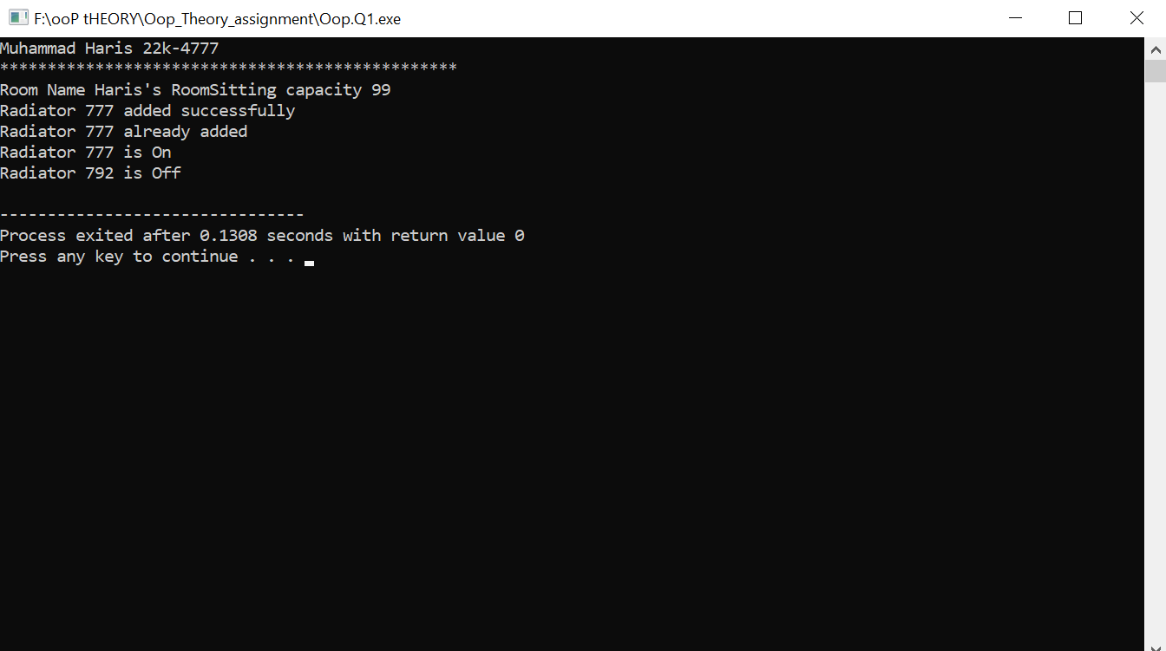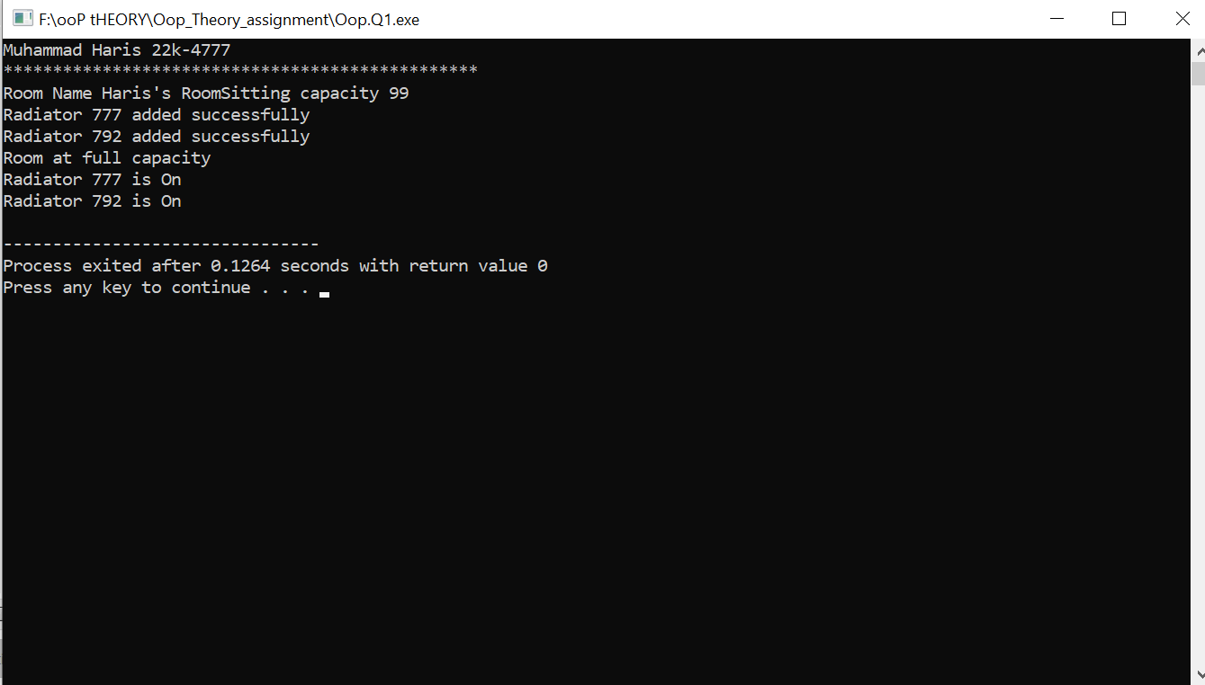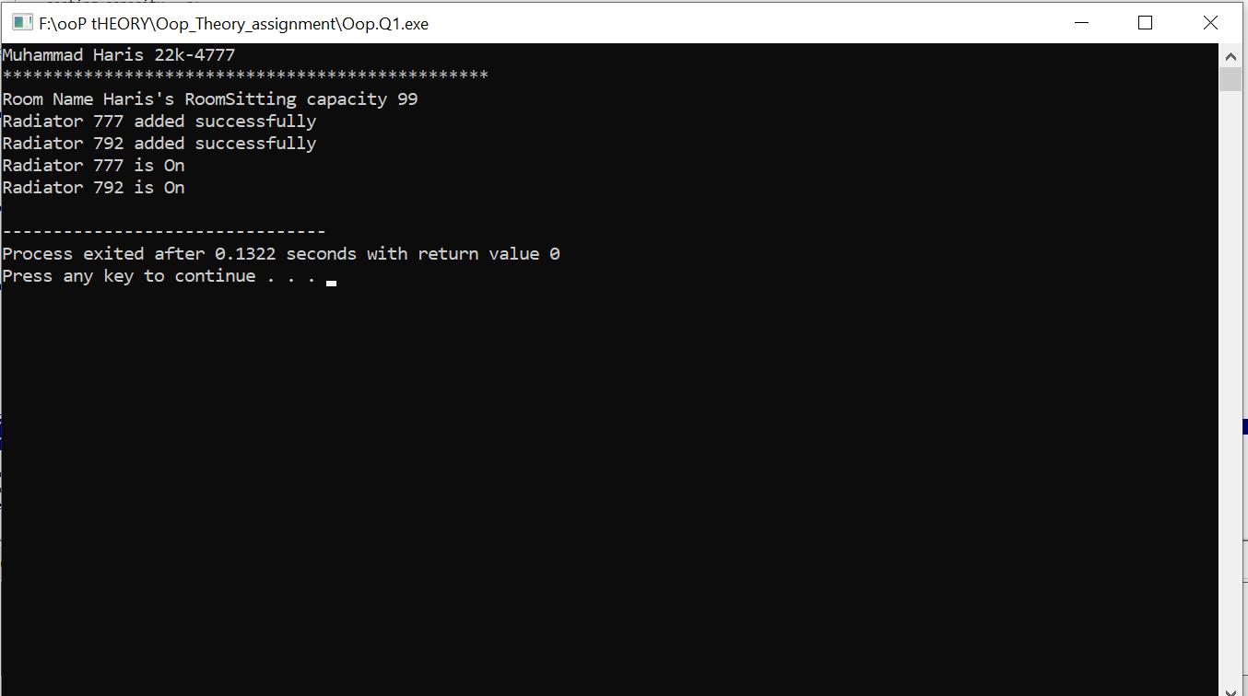

Q2:

#include<iostream>

#include<vector>

using namespace std;

class Admin;

class DataScientist{

    private:

string firstname,lastname,highereduction,country;

int age,number_of_answer,number_of_question,Id;

public:

DataScientist()

{

    number_of_answer=0;

    number_of_answer=0;

}

DataScientist(string f,string l,string h,string c,int age,int id)

{

    firstname=f;

    lastname=l;

    highereduction=h;

country=c;

this->age=age;

Id=id;

}

void set_name(string name,int a)

{

    data[a].firstname=name;

}

void set_last(string name,int a)

{

    data[a].lastname=name;

}

void set_country(string name,int a)

{

    data[a].country=country;

}

string get_first(int a)

{

    return data[a].firstname;

}

string get_last(int a)

{

    return data[a].lastname;

}

string get_country(int a)

{

    return data[a].country;

}

void set_age(int ag,int a)

{

    data[a].age=ag;

}

int get_age(int a)

{

    return data[a].age;

}

static const int max=200;

static DataScientist data[max];

static int size;

int check(int id)

{

    for(int i=0;i<size;i++)

    {

        if(data[i].Id==id)

        {

            cout<<"*********************************************************************"<<endl;

            cout<<"Your Name "<<data[i].firstname<<endl<<"Last Name :"<<data[i].lastname<<endl<<"ID :"<<data[i].Id<<endl<<"Number Of Question Asked "<<data[i].number_of_question<<endl<<"Number Of Answer You Gave: "<<data[i].number_of_answer<<endl;

            return i;

        }

    }

    return -1;

}

void question(int id)

{

    string question;

    cout<<"Enter Your Question"<<endl;

    cin>>question;

    data[id].number_of_question++;

}

void answer(int id)

{string ans;

    cout<<"Which is Better Cyber Security Or Data Science (Obviously Cyber ) But You Your Answer"<<endl;

    cin>>ans;

    data[id].number_of_answer++;

}

static int append(string name,string l,string h,string c,int age,int id)

{

    int flag=0;

    if(size>=max)

    {

        cout<<"Out Of Capacity User"<<endl;

        return -1;

    }

    else{

    for(int i=0;i<size;i++)

    {

        if(id==data[i].Id)

        {

            cout<<"ID Already Exist"<<endl;

                flag=1;

            return -3;

        }

    }

}

        if ((size < max)&&(flag!=1)) {

        data[size]=DataScientist(name,l,h,c,age,id);

        size++;

        cout<<"User Added Successfully"<<endl;

        return 0;

}

return 0;

}

};

class Admin

{

    private:

    int admin_id;

    string first_name,last_name,country;

    int age;

    static int total_user;

    string pass;

    public:

        Admin()

        {

        }

    Admin(string f,string l, string c,int age,string pass1)

    {

        this->admin_id=4777;

        this->first_name=f;

        this->last_name=l;

        this->age=age;

        this->country=c;

        this->pass=pass1;

    }

    void increase()

    {

        total_user++;

    }

    int check(string pass2)

    {

        if(pass==pass2)

        {

            return 0;

        }

        else return -1;

    }

    void set_firstname(string name)

    {

        first_name=name;

    }

    void set_lastname(string name)

    {

        last_name=name;

    }

    void set_country1(string name)

    {

        country=name;

    }

    void set_age1(int ag)

    {

        age=ag;

    }

    string get_first()

    {

        return first_name;

    }

    string get_last()

    {

        return last_name;

    }

    string get_country()

    {

        return country;

    }

    int get_age()

    {

        return age;

    }

    int get_user()

    {

        return total_user;

    }

    int get_id()

    {

        return admin_id;

    }

};

DataScientist DataScientist::data[DataScientist::max];

int DataScientist::size=0;

int Admin::total_user=0;

int main(){

        cout<<"Muhammad Haris 22k-4777"<<endl;

            cout<<"************************************************"<<endl;

    Admin a1;

    string pass1;

    DataScientist s;

string f,l,h,c,rollno;

int age;

int id;

string choice;

char ch;

cout<<"Enter Your First Name"<<endl;

cin>>f;

cout<<"Enter Your Last Name"<<endl;

cin>>l;

cout<<"Enter Your Age"<<endl;

cin>>age;

cout<<"Create A Password"<<endl;

cin>>pass1;

cout<<"Enter Your Country"<<endl;

cin>>c;

rollno="22k-4777";

a1=Admin(f,l,c,age,pass1);

cout<<"Admin ID Created Succesfully"<<endl;

cout<<"**************************"<<endl;

while(1){

cout<<"If You are Admin Enter (Admin)"<<endl;

cout<<"**************"<<endl;

cout<<"If You are (User) Enter User"<<endl;

cout<<"**************"<<endl;

cout<<"If You Want to create Your Account As a User Enter (Create)"<<endl;

cout<<"**************"<<endl;

cout<<"If You Want to end the program enter Y/y"<<endl;

cin>>choice;

if((choice =="y")||(choice=="Y"))

{

    cout<<"By"<<endl;

    return 0;

}

while(1){

    if((choice=="admin")||(choice=="Admin")||(choice=="Create")||(choice=="create")||(choice=="User")||(choice=="user"))

    break;

    else{ cout<<"Wrong Choice Enter Correctly(Also Case Sensitive)"<<endl;

cin>>choice;

    }

}

if((choice=="User")||(choice=="user"))

{

cout<<"Enter Your Roll No Ex:22k-4777 "<<endl;

cin>>rollno;

id = std::stoi(rollno.substr(4, 7));

int a=s.check(id);

if(a<0)

{

    cout<<"Cannot Find Your Id Or May Be You Did Not Create Account"<<endl;

}

else{

cout<<"Do You Want Ask Question Or Answer Question if Yes Enter Question If You Want to Answer The Question Enter Answer"<<endl;

cin>>choice;

if(choice=="Answer"||choice=="answer")

{

    s.answer(a);

}

if(choice=="Question"||choice=="question")

{

    s.question(a);

}

cout<<"Do You Want To Update Your First Name Enter (First) If Last Name Enter (Last) if Country Enter Country(Country) Or Age Enter (Age)\n For Exit Enter No::"<<endl;

cin>>choice;

while(1)

{

    if((choice=="First")||(choice=="first")||(choice=="Last")||(choice=="last")||(choice=="country")||(choice=="Country")||(choice=="Age")||(choice=="age"))

    {

        break;

    }

    else if((choice=="No")||(choice=="no"))

    break;

      else{ cout<<"Wrong Choice Enter Correctly(Also Case Sensitive)"<<endl;

cin>>choice;

    }

}

if((choice=="First")||(choice=="first"))

{

    cout<<"Enter First Name"<<endl;

    cin>>f;

    s.set_name(f,a);

    cout<<"Your Name Was Updated to :"<<s.get_first(a);

}

else if((choice=="last")||(choice=="Last"))

{

    cout<<"Enter last Name"<<endl;

    cin>>f;

    s.set_last(f,a);

    cout<<"Your Last Name Was Updated to :"<<s.get_last(a);

}

else if((choice=="Country")||(choice=="country"))

{cout<<"Enter Country Name"<<endl;

    cin>>f;

    s.set_country(f,a);

    cout<<"Your Country Was Updated to :"<<s.get_country(a);

}

else if((choice=="Age")||(choice=="age"))

{

    cout<<"Enter Age:"<<endl;

    cin>>age;

    s.set_age(age,a);

    cout<<"Your Age Was Updated "<<s.get_age(a)<<endl;

}

}

}

if((choice=="Create")||(choice=="create"))

{

cout<<"Enter Your First Name"<<endl;

cin>>f;

cout<<"Enter Your Last Name"<<endl;

cin>>l;

cout<<"Enter Your Higher Education"<<endl;

cin>>h;

cout<<"Enter Your Country"<<endl;

cin>>c;

cout<<"Enter Your Age "<<endl;

cin>>age ;

cout<<"Enter Your Role No:"<<endl;

cin>>rollno;

id = std::stoi(rollno.substr(4,7));

if(DataScientist::append(f,l,h,c,age,id)>=0)

{

    DataScientist::append(f,l,h,c,age,id);

    cout<<"**********************************"<<endl;

a1.increase();

}

}

if((choice=="Admin")||(choice=="Admin"))

{

    cout<<"Enter Password"<<endl;

    cin>>pass1;

    if(a1.check(pass1)==0){

        cout<<"***************************************"<<endl;

        cout<<"First Name "<<a1.get_first()<<endl<<"Last Name "<<a1.get_last()<<endl<<"Age "<<a1.get_age()<<endl<<"Country "<<a1.get_country()<<endl<<"ID"<<a1.get_id()<<endl;

cout<<"Numbers Of Users Are "<<a1.get_user()<<endl;

    cout<<"**********************************************"<<endl;

    cout<<"Enter y if you want to Update Your Info"<<endl;

    cin>>choice;

    if((choice=="Y")||(choice=="y"))

    {

        cout<<"What Do You want to Update Your Information\nTo Update Name Enter(Name)\nTo Update Last Name Enter (Last)\nTo Update Enter Country Enter Country\nTo Update Age Enter (Age)"<<endl;

        cin>>choice;

        while(1){

        if((choice=="Name")||(choice=="name")||(choice=="last")||(choice=="Last")||(choice=="country")||(choice=="Country")||(choice=="Age")||(choice=="age"))

        {

            break;

        }

        else{

        cout<<"Enter Correct Also Case Sensitive"<<endl;

        cin>>choice;

    }

    }

    }

    cout<<"**********************************"<<endl;

    if((choice=="Name")||(choice=="name"))

    {

        cout<<"Enter New Name"<<endl;

        cin>>f;

        a1.set_firstname(f);

        cout<<"Name Was Changed to "<<f<<endl;

    }

    else if((choice=="Last")||(choice=="last"))

    {

        cout<<"Enter Last Name"<<endl;

        cin>>l;

        a1.set_lastname(l);

        cout<<"Name Was Changed to "<<l<<endl;

    }

    else if((choice=="Country")||(choice=="country"))

    {

        cout<<"Enter Country"<<endl;

        cin>>c;

        a1.set_country1(c);

        cout<<"Name Was Changed to "<<c<<endl;

    }

    else if((choice=="age")||(choice=="Age"))

    {

        cout<<"Enter Age"<<endl;

        cin>>age;

        a1.set_age1(age);

        cout<<"Age Was Changed to "<<age<<endl;

    }

}

}

}

}

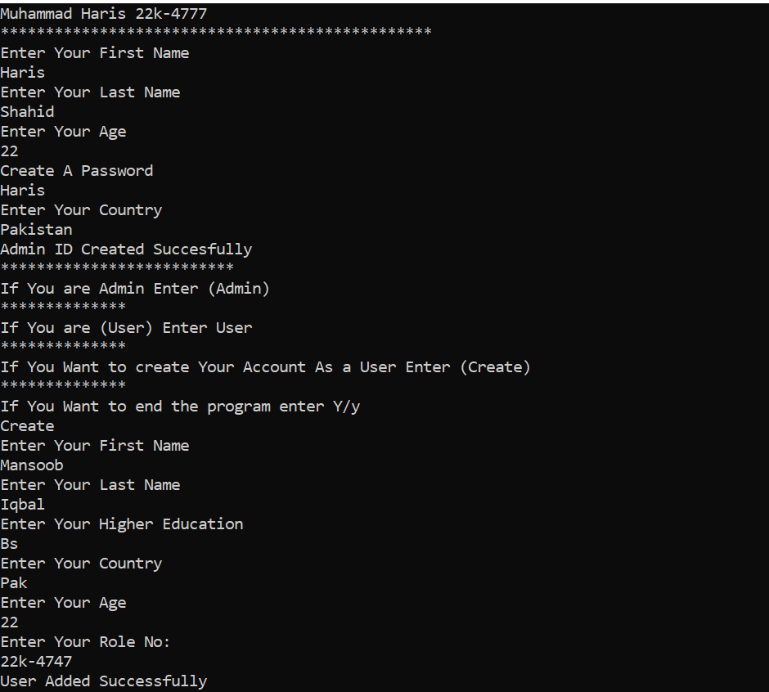

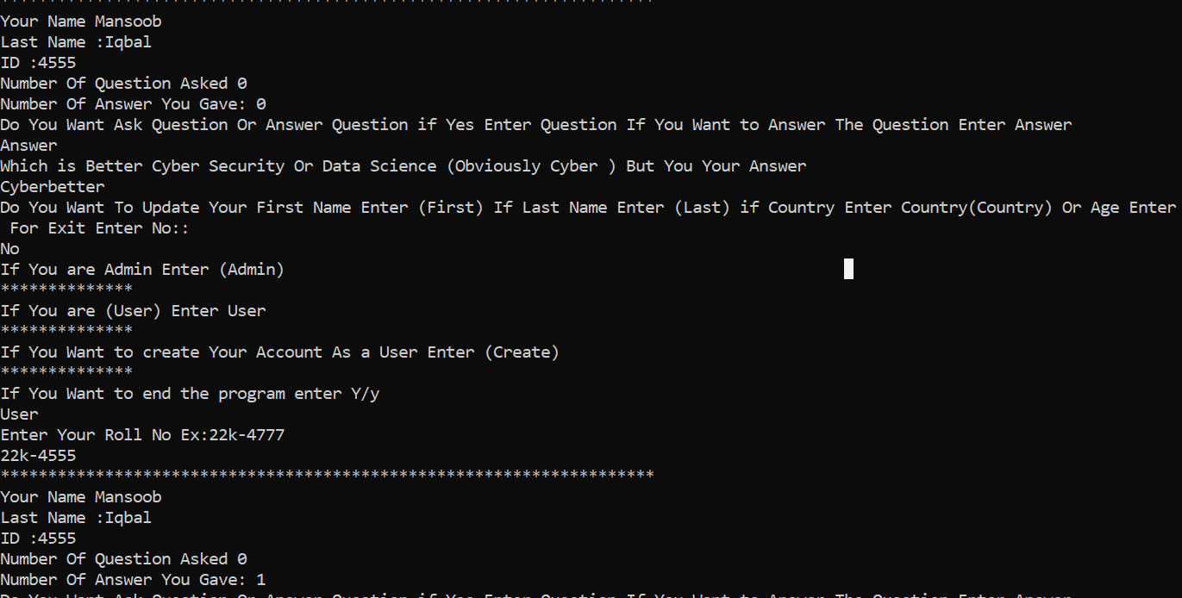

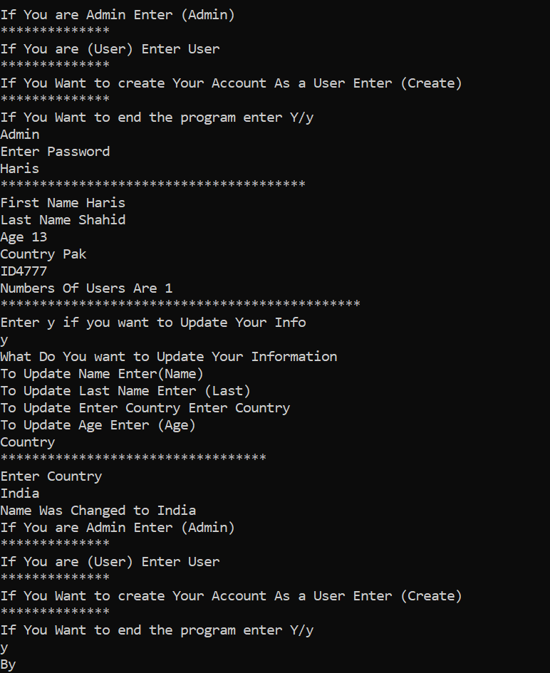

Q3:

#include<iostream>

using namespace std;

#include<string>

#include<ctime>

class HeartRates{

private:

string name;

string id;

int day;

int year;

int month;

public:

HeartRates(string name, int d,int m,int y) {

    day=d;

    month=m;

    year=y;

this->name = name;

string roll_no="22k-4777";

this->id = roll_no.substr(4,7);

}

int calculate_age() {

int current_year = 2023;

int age = current_year - year;

return age;

}

int maximum_heart_rate()

{

return 220-calculate_age();

}

string target_heart_range()

{

int first;

int second;

first=maximum_heart_rate()*0.5;

second=maximum_heart_rate()*0.85;

return to_string(first)+"->"+to_string(second);

}

string get_info()

{

    string date_of_birth=to_string(day)+"/"+to_string(month)+"/"+to_string(year);

return name+"\n"+id+"\n"+date_of_birth+"\n"+"Age : "+to_string(calculate_age())+"\n"+"Maximum Heart Rate :"+to_string(maximum_heart_rate())+"\n"+"Target Heart Range "+ target_heart_range();

}

};

int main() {

        cout<<"Muhammad Haris 22k-4777"<<endl;

            cout<<"************************************************"<<endl;

string name;

int day,month,year;

cout << "Enter your name: " << endl;

cin >> name;

cout << "Enter your date of birth in this format DD/MM/YYYY: First Enter Date Then Enter Month Then Year for ig 2004 " << endl;

cin >> day>>month>>year;

// Validate input format

while (1) {

if((day>31)||(month>12)||(year<1111)||(year>=2023))

{

    cout<<"Enter Correctly"<<endl;

}

else

break;

}

HeartRates h1(name,day,month,year);

//cout<<h1.calculate_age();

cout<<h1.get_info();

return 0;

}

Q3 Outputs:

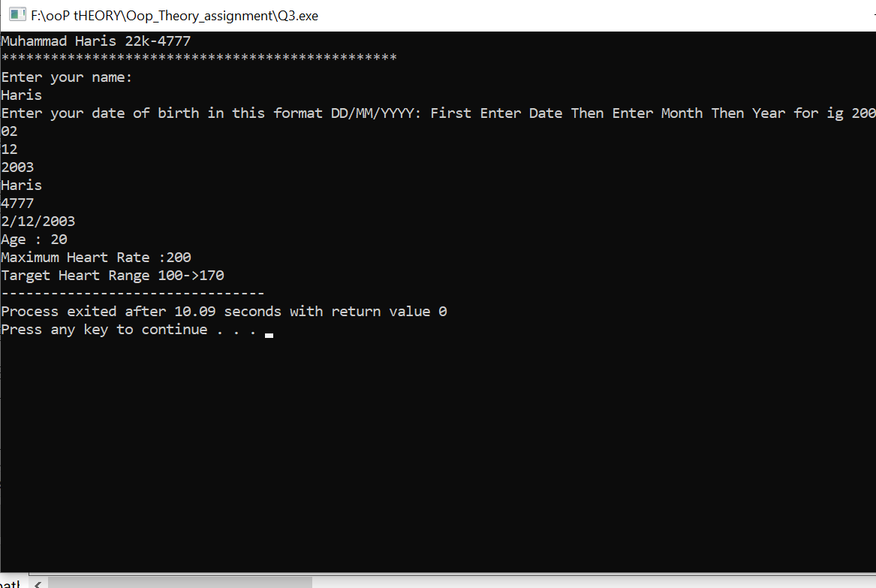

Q4 Code:

#include <iostream>

#include <string>

#include<cstdlib>

#include<ctime>

using namespace std;

class Movie {

private:

    string movies[9] = {"Avengers End Game", "Infinity War", "Civil War", "Khan", "Jawani Phir Nhi Aani", "Life At Fast", "Dday", "CivilWar", "Harley Queen"};

    int array[9] = {2, 12, 3, 2, 4, 5, 7, 7, 9};

public:

    void show() {

        for (int i = 0; i < 9; i++) {

            cout << "Movie Name: " << movies[i] << " is shown at time: " << array[i] << ":00 PM" << endl;

        }

    }

    string get_movies(int name) {

       if(name<10)

       {

       //   cout<<array[name];

        return movies[name];

       }

        return "UnExpectedError"; // return -1 if the movie name is not found

}

int gettime(int name)

       {

        return array[name];

       }

};

class Ticket {

private:

    int row_num;

    int seat_num;

    int ticket_id;

    bool sold;

    string movie;

    int time;

public:

Ticket()

{

}

    Ticket(int r, int s,int id,string m,int t) {

        row_num = r;

        seat_num = s;

        ticket_id=id;

        sold = false;

        this->movie=m;

        this->time=t;

    }

    static const int MAX_TICKETS = 100;

    static Ticket tickets[MAX_TICKETS];

    static int num_tickets;

void append_record(int r, int s, int id,string movie,int time) {

    for (int i = 0; i < num_tickets; i++) {

        if (tickets[i].ticket_id==id && tickets[i].sold ==true) {

            cout << "Sorry, seat is already booked by ticket with ID " << tickets[i].ticket_id << endl;

            return;

        }

    }

    if (num_tickets < MAX_TICKETS) {

        tickets[num_tickets] = Ticket(r, s, id,movie,time);

        tickets[num_tickets].sold=true;

        num_tickets++;

        cout << "Ticket booked successfully" << endl;

       this->check(id); // Add the function call to check the ticket record

    } else {

        cout << "Sorry, no more tickets available" << endl;

    }

}

void check(int id)

{

     for (int i = 0; i < num_tickets; i++) {

        if (tickets[i].ticket_id==id && tickets[i].sold ==true) {

            cout<<"*****************************************"<<endl;

            cout<<"ID == "<<tickets[i].ticket_id<<endl;

            cout<<"Booked Seat No :"<<tickets[i].seat_num<<endl;

            cout<<"Booked Row No :"<<tickets[i].row_num<<endl;

            cout<<"Booked Movie "<<tickets[i].movie<<" at This Time :"<<tickets[i].time<<endl;

            cout<<"************************************************"<<endl;

        }

}

}

};

Ticket Ticket::tickets[Ticket::MAX_TICKETS];

int Ticket::num_tickets = 0;

int main() {

    cout<<"Muhammad Haris 22k-4777"<<endl;

    cout<<"************************************************"<<endl;

Ticket t1;

    Movie my_movie;

    string name;

    string movie;

    int time;

    int r,s;

    int id;

    int num;

    char ch;

    while(1){

    cout<<"Enter Your Name: Means Your Role No in the format 22k-4777"<<endl;

    cin>>name;

    id = std::stoi(name.substr(4, 2));

    cout<<"These Movies Are Available"<<endl;

    my_movie.show();

    cout<<"Which Movies You Wanna to see "<<endl;

    cout<<"Enter Number"<<endl;

    cin>>num;

    if(my_movie.get_movies(num) == "UnExpectedError")

    {

        cout<<"Not Available Or Entered Wrong"<<endl;

            return 0;

    }

    else

    {

        cout<<"This Movie: "<<my_movie.get_movies(num)<<" Is Shown On Time: "<<my_movie.gettime(num)<<":00 PM"<<endl;

        movie=my_movie.get_movies(num);

        time=my_movie.gettime(num);

    }

   s=(rand()%100-10+1)+10;

    //cout<<"Enter Row Number"<<endl;

    r=(rand()%50-10+1)+1;

  Ticket ticket;

ticket.append_record(r, s, id, movie, time);

    cout<<"Do You Wanna to Buy more tickets"<<endl;

    cout<<"If Yes Enter Y/y else no enter N/n"<<endl;

    cin>>ch;

    if((ch=='n')||(ch=='N')){

    break;

}

}

char chic;

cout<<"Do You Want To see Ticket Info"<<endl;

cout<<"If Yes Enter Y else no"<<endl;

cin>>chic;

switch(chic)

{

    case 'Y':

        case 'y':

            cout<<"Enter ID"<<endl;

            cin>>id;

            t1.check(id);

            break;

}

return 0;

}

Q4 Outputs:

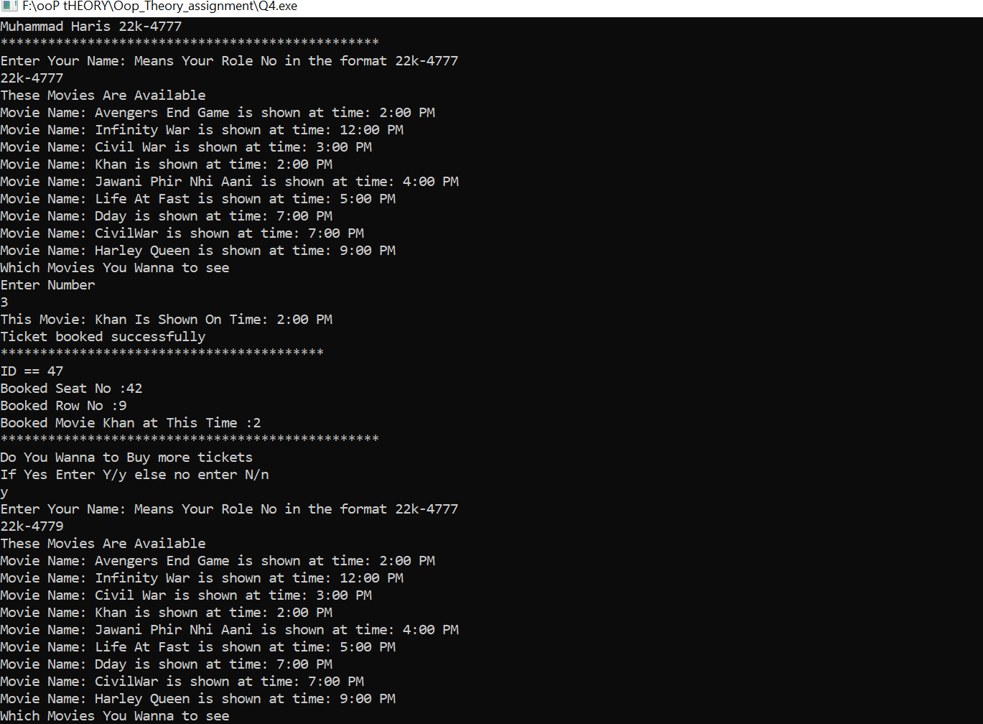

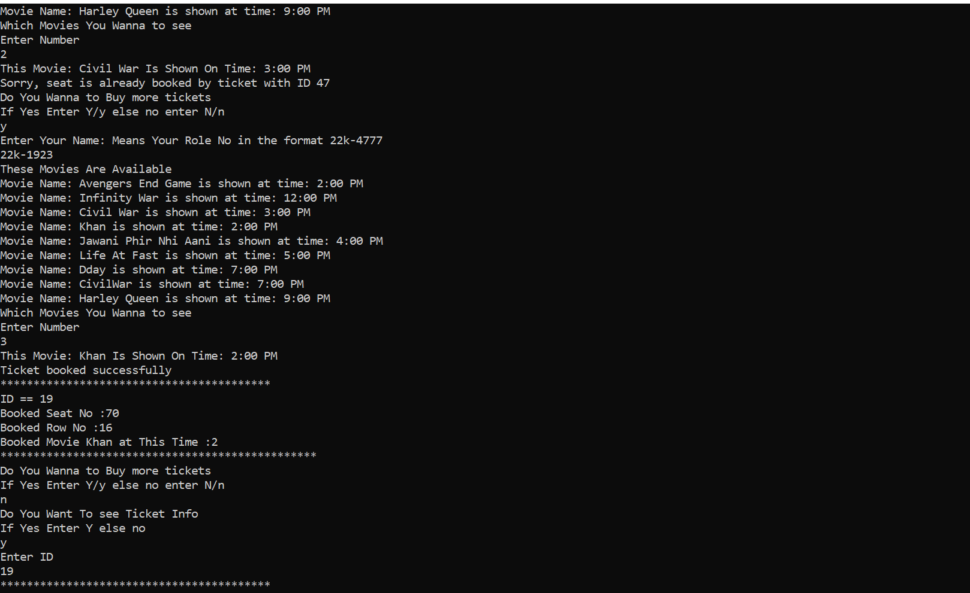

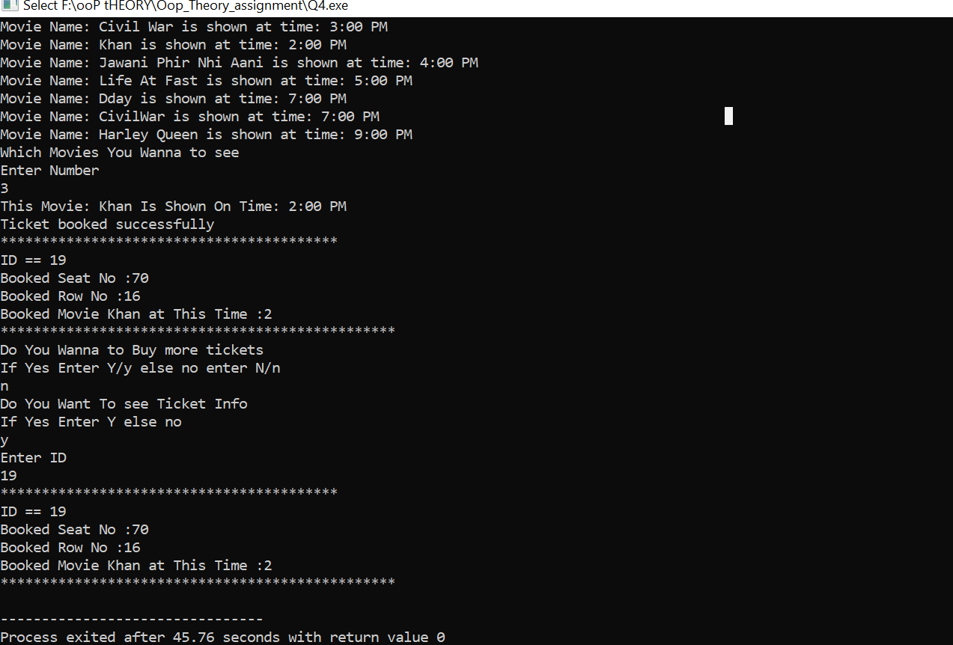

Q5 Code:

#include<iostream>

#include<string>

using namespace std;

class User;

class User{

    private:

    int  id;

    string name;

    int age;

    float height;

    string gender;

    float shoe_size;

    public:

        User(){

        }

    User(int id,string n,float f,string g,float s,int a)

    {

this->id=id;

name=n;

age=a;

height=f;

gender=g;

shoe_size=s;

    }

    void set_name(string name)

    {

        this->name=name;

    }

    void set_age(int a)

    {

        age=a;

    }

    void set_height(float h)

    {

        height=h;

    }

    void set_gender(string Gender)

    {

        gender=Gender;

    }

    void set_shoee_size(float s)

    {

        shoe_size=s;

    }

    string gat_name()

    {

        return name;

    }

    int get_age()

    {

        return age;

    }

    float getheight()

    {

        return height;

    }

    string get_gender()

    {

        return gender;

    }

    float get_shoe_size()

    {

        return shoe_size;

    }

    int get_id()

    {

        return id;

    }

};

class Shoe{

private:

float size;

float width;

string style;

string brand;

string demographic;

public:

    Shoe()

    {

    }

Shoe(float s ,float w,string style,string brand)

{

    size=s;

    width=w;

    this->style=style;

    this->brand=brand;

}

void set_size0(float l)

{

    size=l;

}

void set_width(float l)

{

    width=l;

}

void set_style(string s)

{

    style=s;

}

void set_brand(string b)

{

    brand=b;

}

void set_demographic(string d)

{

    this->demographic=d;

}

float get_size()

{

    return size;

}

float get_width()

{

    return width;

}

string get_style()

{

    return style;

}

string get_brand()

{

    return brand;

}

string get_demographic()

{

    return demographic;

}

void set_dem(User *U1)

{

    if((U1->get_age()>=0)&&(U1->get_age()<=2))

    this->demographic="toddler";

    else if((U1->get_age()>=6)&&(U1->get_age()<=9))

    {

         this->demographic="Process To Child";

    }

    else if((U1->get_age()>=10)&&(U1->get_age()<=12))

    {

         this->demographic="child";

    }

    else if((U1->get_age()>=13)&&(U1->get_age()<=19))

    {

         this->demographic="teenager";

    }

    else if(U1->get_age()>19)

    {

         this->demographic="Adult";

    }

    else {

    cout<<"Enter Wrong Age"<<endl; return;

    }

}

};

void print(User *u1,Shoe *s2)//global function

{

cout<<"Name :"<<u1->gat_name()<<endl;

cout<<"ID"<<u1->get_id()<<endl;

cout<<"Age"<<u1->get_age()<<endl;

cout<<"Height :"<<u1->getheight()<<endl;

cout<<"Gender "<<u1->get_gender()<<endl;

cout<<"Shoe Size: "<<u1->get_shoe_size()<<endl;

cout<<"Shoe Width: "<<s2->get_width()<<endl;

cout<<"Shoe Style :"<<s2->get_style()<<endl;

cout<<"Shoe Brand :"<<s2->get_brand()<<endl;

cout<<"Shoe Demographic :"<<s2->get_demographic()<<endl;

}

int main()

{

    cout<<"Muhammad Haris 22k-4777"<<endl;

    cout<<"************************************************"<<endl;

    Shoe s1;

    User u1;

    string choice;

    string roleno;

    int id[2];

    string name;

    float height;

    string gender;

    float shoe_size;

    float size;

    float width;

    string style;

    string brand;

    int age;

    char cho;

    cout<<"Enter Your Name : "<<endl;

    cin>>name;

    cout<<"Enter Your Role_No :"<<endl;

    cin>>roleno;

    id[0]=std::stoi(roleno.substr(0,2));

    id[1]=std::stoi(roleno.substr(4));

    cout<<"Enter Your Height"<<endl;

    cin>>height;

    cout<<"Enter Your Gender"<<endl;

    cin>>gender;

    cout<<"Enter Your Age"<<endl;

    cin>>age;

    cout<<"Enter  Shoe_size :"<<endl;

    cin>>shoe_size;

    size=shoe_size;

    cout<<"Enter Width of Shoe"<<endl;

    cin>>width;

    cout<<"Enter Style of Your Shoe"<<endl;

    cin>>style;

    cout<<"Enter Brand Of Your Shoe"<<endl;

    cin>>brand;

u1=User(id[0],name,height,gender,shoe_size,age);

s1=Shoe(size,width,style,brand);

s1.set_dem(&u1);

cout<<"*****************************************"<<endl;

while(1){

    cout<<"*****************************************"<<endl;

cout<<"You Have Three Option IF You Want to see The Information Of Shoe and User Enter S\nElse If You Wanna to Update Record Of Shoe Enter P "<<endl;

cout<<"else you want to update the information of user Enter U"<<endl;

cout<<"Enter N For Ending Program"<<endl;

cin>>cho;

if((cho=='N')||(cho=='n'))

{

    cout<<"Good Byyyy"<<endl;

    return 0;

}

while(1){

if((cho=='S')||(cho=='s')||(cho=='p')||(cho=='P')||(cho=='U')||(cho=='u'))

{

    break;

}

cout<<"Enter Correctly"<<endl;

cin>>choice;

}

switch(cho){

case 'S':

    case 's':

print(&u1,&s1);

break;

case 'U':

    case 'u':

    do{

    cout<<"Which Thing You Want To Update You Can Update Your Name Age Gender Shoe Size  Or Height"<<endl;

    cout<<"For Update Enter Their Name Ig For Shoe Size Enter Shoe\nFor Name Enter Name\nFor Age Enter Age\n For Gender Enter Gender"<<endl;

    cin>>choice;

    if((choice=="Name")||(choice=="name"))

    {

        cout<<"Enter Name"<<endl;

        cin>>name;

        cout<<"Name Changed This ->"<<u1.gat_name();

        u1.set_name(name);

        cout<<": To This "<<u1.gat_name();

        }

         else if((choice=="Age")||(choice=="age"))

    {

        cout<<"Enter Age"<<endl;

        cin>>age;

        cout<<"Age Changed This -> "<<u1.get_age();

        u1.set_age(age);

        cout<<": To This  "<<u1.get_age();

        }

       else   if((choice=="Gender")||(choice=="gender"))

    {

        cout<<"Enter Gender"<<endl;

        cin>>gender;

        cout<<"Gender Changed This ->"<<u1.get_gender();

        u1.set_gender(gender);

        cout<<": To This "<<u1.get_gender();

        }

         else if((choice=="Shoe")||(choice=="shoe"))

    {

        cout<<"Enter New Size"<<endl;

        cin>>shoe_size;

        cout<<"Size Changed This ->"<<u1.get_shoe_size();

        u1.set_shoee_size(shoe_size);

        cout<<": To This "<<u1.get_shoe_size();

        }

           else if((choice=="Height")||(choice=="height"))

    {

        cout<<"Enter New Height"<<endl;

        cin>>height;

        cout<<"Height Changed This ->"<<u1.getheight();

        u1.set_height(height);

        cout<<": To This "<<u1.getheight();

        }

    cout<<"Do You Want to Update Again If Yes Enter Yes Else No"<<endl;

    cin>>choice;

    }while((choice=="Yes")||(choice=="yes"));

    break;

case 'P':

    case 'p':

    do{

    cout<<"Which Thing You Want To Update You Can Update Your Shoe Size, Width,Style,Brand Demographic will be set automatically"<<endl;

    cout<<"For Update Enter Their NameIg For  Size Enter Size (Case Sensitive)"<<endl;

    cin>>choice;

    if((choice=="Size")||(choice=="size"))

    {

        cout<<"Enter Size"<<endl;

        cin>>size;

        cout<<"Size Changed This ->"<<s1.get_size();

        s1.set_size0(size);

        cout<<": To This "<<s1.get_size();

        }

     else  if((choice=="Width")||(choice=="width"))

    {

        cout<<"Enter Width"<<endl;

        cin>>width;

        cout<<"Width Changed This ->"<<s1.get_width();

        s1.set_width(width);

        cout<<": To This "<<s1.get_width();

        }

       else   if((choice=="Style")||(choice=="style"))

    {

        cout<<"Enter Style"<<endl;

        cin>>style;

        cout<<"Style Changed This -> "<<s1.get_style();

        s1.set_style(style);

        cout<<": To This "<<s1.get_style();

        }

         else if((choice=="Brand")||(choice=="brand"))

    {

        cout<<"Enter Brand"<<endl;

        cin>>brand;

        cout<<"Size Changed This ->"<<s1.get_brand();

        s1.set_brand(brand);

        cout<<": To This "<<s1.get_brand();

        }

    cout<<" Do You Want to Update Again If Yes Enter Yes Else No"<<endl;

    cin>>choice;

    }while((choice=="Yes")||(choice=="yes"));

    break;

}

}

}

Q5 Output:

